[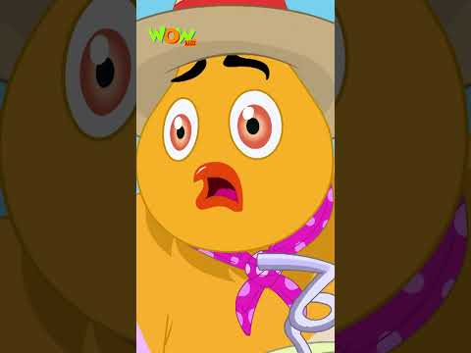](https://www.youtube.com/embed/dy1Be7s3G08?feature=oembed)

[ina meena tikka](https://www.youtube.com/shorts/dy1Be7s3G08)